YAML Configuration File

What is a YAML Configuration File?
# Source: AI Source: Provided by: [Data Path: Persons Table -> ID Column: 1, Name_En Column: Motasem Essam] -> From: [ChatGPT] on [1/26/2026]
A YAML configuration file is a human-readable file format used to store configuration settings for an application.
- YAML stands for “YAML Ain’t Markup Language” (yes, it’s recursive!).
- It’s often used in DevOps, web applications, and deployment pipelines.
- Unlike JSON, YAML is less verbose and easier to read for humans because it uses indentation instead of braces and brackets.

Key Characteristics
# Source: AI Source: Provided by: [Data Path: Persons Table -> ID Column: 1, Name_En Column: Motasem Essam] -> From: [ChatGPT] on [1/26/2026]
- Format:
  - Text-based, indentation defines hierarchy
  - Supports scalars (strings, numbers, booleans), lists, and dictionaries (key-value pairs)
  - Comments are allowed using #
- File Extensions: .yaml or .yml
- Purpose:
  - Store application configuration, environment settings, or deployment configs
  - Often used with Docker, Kubernetes, CI/CD tools

Example YAML Configuration File
# Source: AI Source: Provided by: [Data Path: Persons Table -> ID Column: 1, Name_En Column: Motasem Essam] -> From: [ChatGPT] on [1/26/2026]
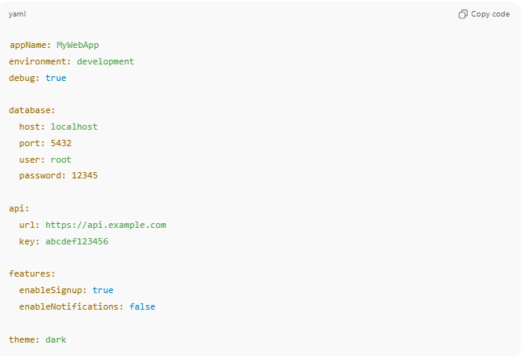
config.yaml
appName: MyWebApp
environment: development
debug: true

database:
host: localhost
port: 5432
user: root
password: 12345

api:
url: https://api.example.com
key: abcdef123456

features:
enableSignup: true
enableNotifications: false

theme: dark
- database → Nested mapping for DB settings
- features → Nested mapping for feature toggles
- Indentation (usually 2 spaces) shows hierarchy

How to Use in Code
# Source: AI Source: Provided by: [Data Path: Persons Table -> ID Column: 1, Name_En Column: Motasem Essam] -> From: [ChatGPT] on [1/26/2026]
Python Example
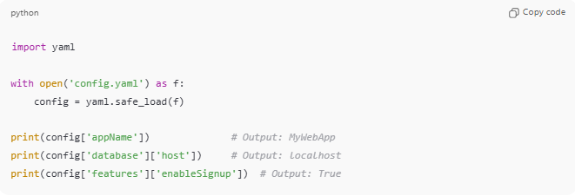
import yaml

with open('config.yaml') as f:
config = yaml.safe_load(f)

print(config['appName']) # Output: MyWebApp
print(config['database']['host']) # Output: localhost
print(config['features']['enableSignup']) # Output: True
Node.js Example
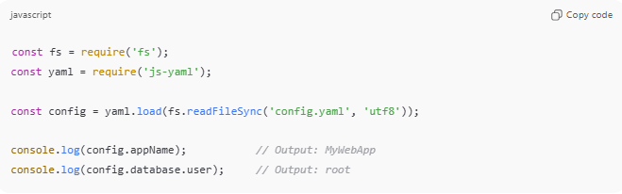
const fs = require('fs');
const yaml = require('js-yaml');

const config = yaml.load(fs.readFileSync('config.yaml', 'utf8'));

console.log(config.appName); // Output: MyWebApp
console.log(config.database.user); // Output: root

Advantages of YAML
# Source: AI Source: Provided by: [Data Path: Persons Table -> ID Column: 1, Name_En Column: Motasem Essam] -> From: [ChatGPT] on [1/26/2026]
- ✅ Very human-readable (clean, less clutter than JSON or XML)
- ✅ Supports nested structures and lists
- ✅ Allows comments
- ✅ Widely used in DevOps (Docker Compose, Kubernetes)
Disadvantages
- ❌ Indentation-sensitive (errors if spacing is wrong)
- ❌ Slightly slower to parse than JSON
- ❌ Not supported natively in all programming languages

💡 Analogy:
# Source: AI Source: Provided by: [Data Path: Persons Table -> ID Column: 1, Name_En Column: Motasem Essam] -> From: [ChatGPT] on [1/26/2026]
If a JSON config file is a blueprint with boxes and braces, a YAML config file is a handwritten instruction sheet—easier to read and edit, but indentation mistakes can break it.

